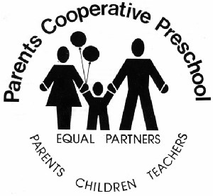Snack Time Nutritional Guidelines
In accordance with Wisconsin State Licensing Guidelines, on your snack day, you will be required to provide 3 items for your child’s classroom.
Item #1 One Fruit or Vegetable Choice

Cucumbers
Broccoli
Green Beans
Sweet Bell Peppers
Sugar Snap Peas
Carrots
Celery
Veggie “Matchsticks”
Strawberries
Raspberries
Blueberries
Oranges
Apples
Grapes
Melon
Peaches
Pears
Raisins
Pineapple
Banana

Item #2 One Whole Grain OR Dairy/Protein Choice

100% whole wheat bread
100% whole wheat bagels
100% whole wheat English muffin
100% whole wheat crackers
Oatmeal
Shredded Wheat Cereal
Toasted Oat Cereal
Whole wheat pretzels
Graham Crackers/Sticks
Whole wheat tortillas
Whole wheat goldfish
Air/natural popcorn
Granola bars

Low-fat yogurt
Low-fat frozen yogurt
Low-fat string cheese
Low-fat pudding
Low-fat cottage cheese
Hard/natural cheeses
Hummus
Bean dip

Item #3 100% Fruit Juice OR Milk to drink

The following items are excluded and do not meet the state nutritional requirements:
potato chips, cheese/peanut butter filled crackers, teddy grahams, vanilla wafers, Sunny D type juices.

Here are a few snack time combination ideas to get you started. Remember to have fun and get creative! Have your child help you choose from the list what they would like to share with their friends:
- Apple slices, low-fat yogurt for dipping, milk
- Whole wheat tortilla rolled up with cream cheese and veggie matchsticks, cut into pinwheels, juice
- Cucumber slices, hummus for dipping, milk
- Graham cracker/banana slice sandwiches, milk
- Snack mix: Air popped popcorn, raisins, goldfish, juice
- Celery sticks, low-fat cottage cheese for dipping, juice
- Fruit and cheese Kabobs, milk

These websites offer fun and nutritious snack time ideas:

http://www.snackpicks.com/en_US/healthy-snacking.html
http://www.superhealthykids.com/healthy-kids-recipes/category/snacks.php
http://www.parents.com/toddlers-preschoolers/feeding/healthy-snacks/
http://pinterest.com/skinnyms/healthy-snacks-for-kids/

